**LONDON STARS EDUCATION CENTRE**

**P.2 CLASS EASTER PACKAGE FOR TERM I 2024**

**Name: ………………………………………………………………………………….**

**Literacy I**

1. **Underline the sources of school needs.**

Parents, plants, blanks, neighbours, market

1. How do schools meet their needs?
2. ________________________________________________
3. _________________________________________________
4. Mention three ways of keeping the school clean.
5. _______________________________________________
6. ________________________________________________
7. _________________________________________________
8. **Draw these things we use to keep our school clean.**

|  |  |  |
| --- | --- | --- |
|  |  |  |
| dustbin | brooms | rag |

1. **Write the uses of these things.**
2. slasher _____________________________________________
3. dustbin ____________________________________________
4. Name the part of the body used for hearing.

___________________________________________________________________

1. Give any one use of the sun to people.

___________________________________________________________________

1. Write any two ways farmers care for the crops.
2. ________________________________________________________________
3. ________________________________________________________________
4. **Name this garden tool.**

___________________________________________________________

1. Identify any two common diseases in our community.

(i)_____________________________ (ii) _________________________________

1. Give the meaning of the term “domestic animals.”

___________________________________________________________________

1. Give one importance of a dog at home.

___________________________________________________________________

1. Why do people boil water for drinking?

___________________________________________________________________

1. **Draw these common plants found in our environment.**

|  |  |
| --- | --- |
|  |  |
| sugarcane plant | banana plant |

**Literacy II**

**Arrange the words to make correct sentences.**

1. city Kampala capital is the.

________________________________________________________

1. your she is sister?

________________________________________________________

1. sick people treats a doctor.

______________________________________________________

1. used for a horse is transport.

______________________________________________________

1. a has blue she pen.

______________________________________________________

1. **Form correct words from the box and write them.**

|  |  |  |  |  |
| --- | --- | --- | --- | --- |
| w | u | c | a | t  a _________________________  b __________________________  c __________________________  d __________________________ |
| c | h | i | c | k |
| u | e | i | c | k |
| b | n | e | s | t |

1. **Construct sentences using these words.**
2. play _______________________________________________
3. come _____________________________________________
4. wash ______________________________________________
5. **Form correct sentences from the table.**

|  |  |
| --- | --- |
| I don’t like | eggs.  black shoes.  snakes.  posho and beans  soldiers. |

1. ______________________________________________________
2. ______________________________________________________
3. ______________________________________________________
4. _______________________________________________________
5. _______________________________________________________

**Mathematics**

1. Draw tens and ones.
2. 41 __________________ b) 13 ___________________
3. T O

___ ____ = _____

1. What is the time?

____________________________________

**B**

**A**



**10L**

**20L**

1. Which container holds 20 litres?
2. Which container holds less litres of water?
3. 20 litres + 10 litres =
4. Draw a set of 5 balls.
5. What is a subset?

____________________________________________________________

1. **Make two sub-sets from the big set.**
2. **Multiply:**
3. 2 4 b) 4 x 5 =

x 2

1. **(a) Name these shapes**
2. **Match correctly**

fourteen 4

forty 14

four 4th

fourth 40

**English**

**Write in short form.**

1. February ___________
2. Has not ____________
3. Is not _____________
4. Do no _____________
5. We have ____________

**Fill the gaps with the short form of the word in brackets.**

1. She ________________ go out alone at night. (cannot)
2. ________________ jumping now. (we are)
3. They _____________ eat food. (did not)
4. The cat ______________ running. (is not)

**Punctuate the following sentences correctly.**

1. bees give us honey

________________________________________________________

1. what is your name

________________________________________________________

1. Joy Jesca Jackie and Ben are in class.

________________________________________________________

1. No they will not come

________________________________________________________

1. Is she playing netball

________________________________________________________

1. **Arrange these words in alphabetical order.**
2. food, desk, bench

_________________________________________________________________

1. son, aunt, mother, father

_________________________________________________________________

1. **Use ‘a’ or ‘an’ to complete the sentences.**
2. Who has ______ umbrella?
3. Mungo is wearing ______ vest.
4. **Write the short forms of these words.**
5. Sunday ____________________
6. has not __________________
7. **Punctuate these sentences.**
8. my father is a doctor

_________________________________________________________________

1. why didn’t you come to school on friday

_________________________________________________________________

**RE**

1. Who heads a family?

______________________________________________________

1. Give the meaning of the following names.
2. Jesus _____________________________
3. Peter _____________________________
4. Deborah _________________________
5. Emmanuel _______________________
6. **Fill in the missing letters.**
7. fa ____r
8. h ____nest
9. g ____ft
10. Who died on the cross for our sins?

________________________________________________________

1. List down any two gifts from God.
2. __________________________________________________
3. __________________________________________________
4. Who created you and me?

________________________________________________________

1. Write down three roles of the mother at home.
2. _______________________________________________
3. ________________________________________________
4. __________________________________________________
5. What is a home?

_______________________________________________________________________________________________________________________________________________

**Luganda**

**Jjuzaamu ekigambo ekituufu.**

1. Omusajja atema ________________________.
2. Omuwala abaka _______________________.

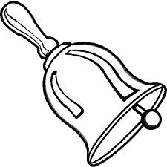

1. Omusomesa akuba ______________________.

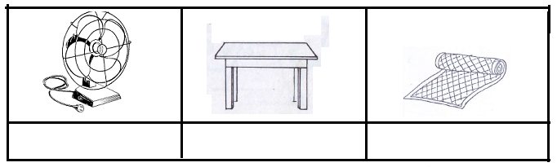

1. Omukazi aluka ___________________________.

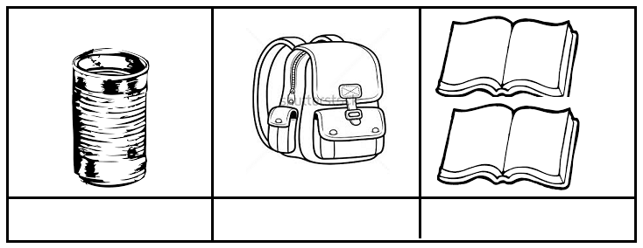

1. Kato asoma ________________________.
2. **Soma era okube ekifaananyi.**

|  |  |  |  |
| --- | --- | --- | --- |
| omukeeka | omuti | ekimuli | ekitabo |
|  |  |  |  |
| omuwala | ekikopo | oluso | omusota |
|  |  |  |  |

**Parent’s comment: …………………………………………………………**

**Signature: …………………………………………………………………….**